Exercise 1

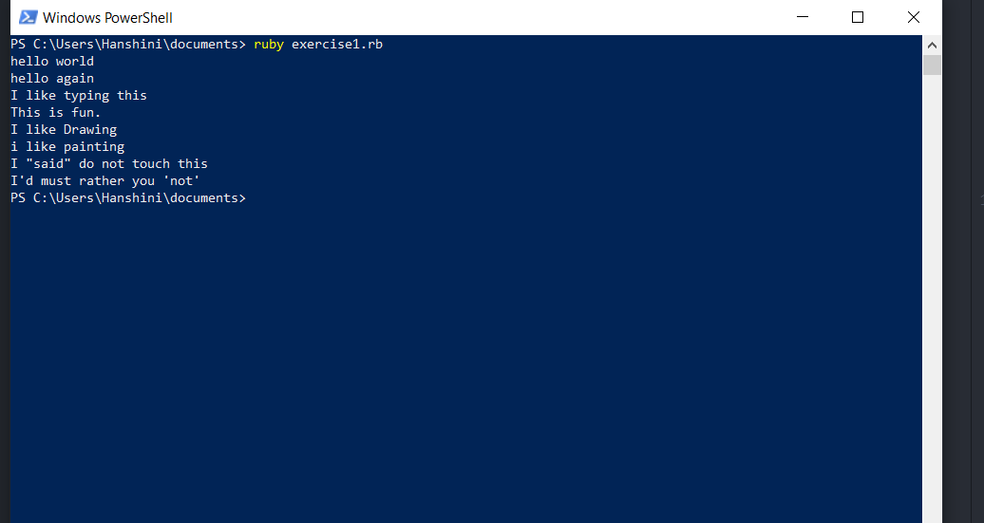

Exercise 2

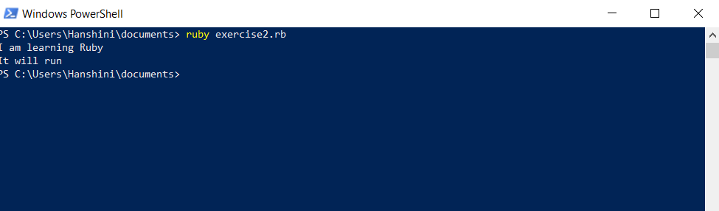

Exercise 3

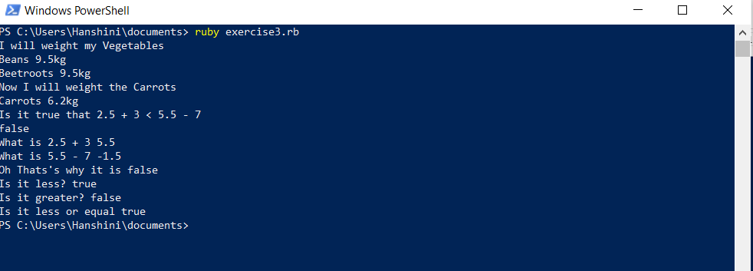

Exercise 4

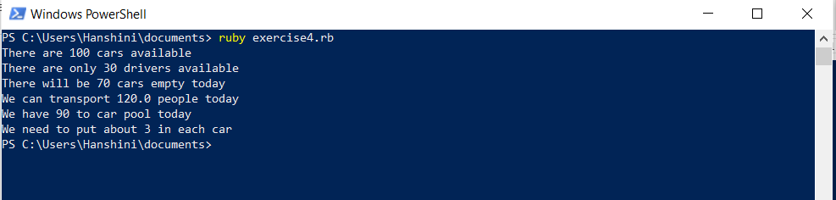

Exercise 5

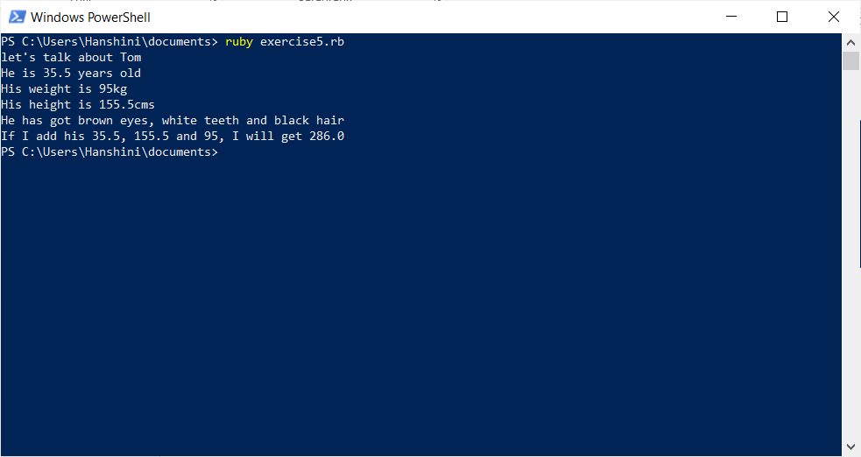

Exercise 6

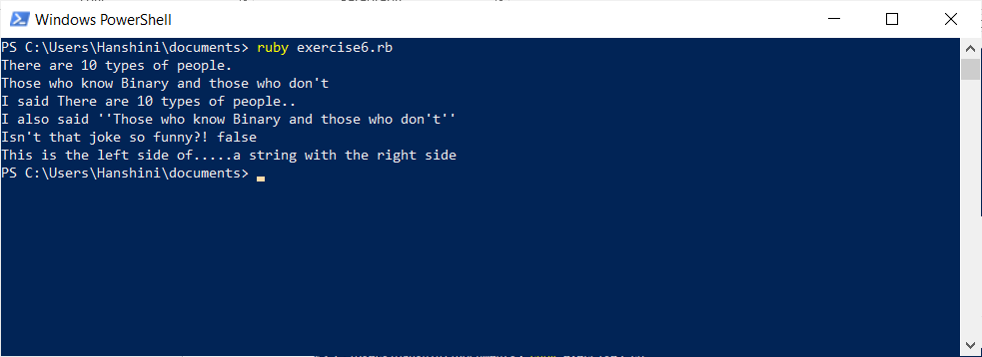

Exercise 7

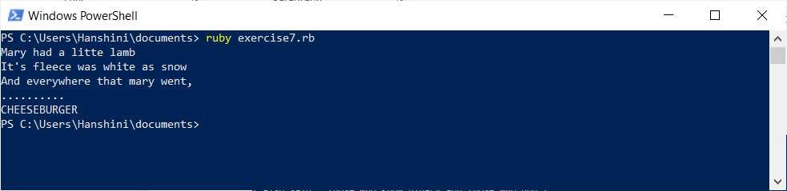

Exercise 8

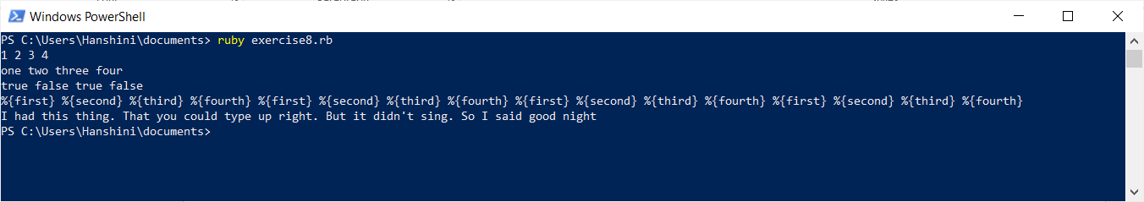

Exercise 9

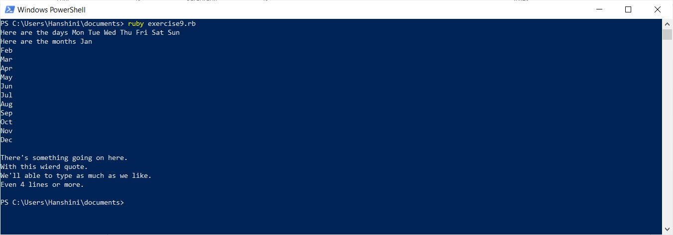

Exercise 10

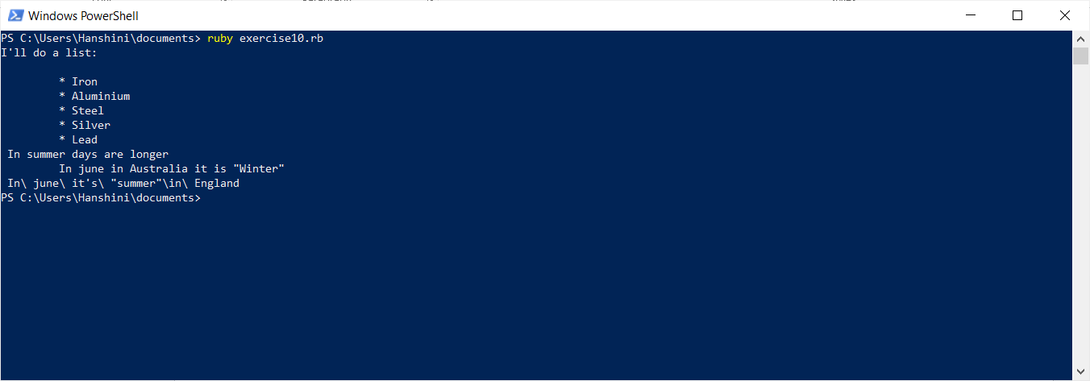

Exercise 11

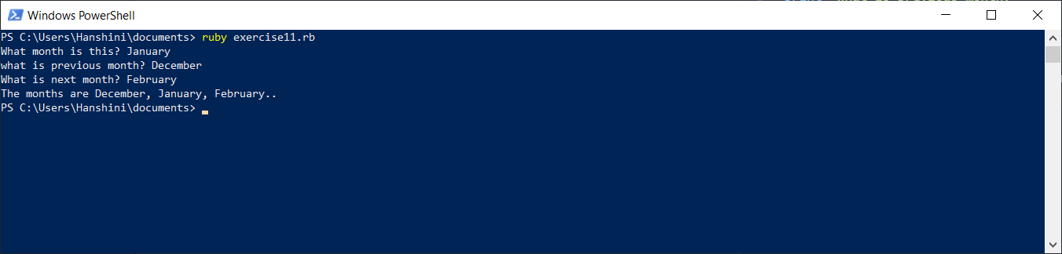

Exercise12

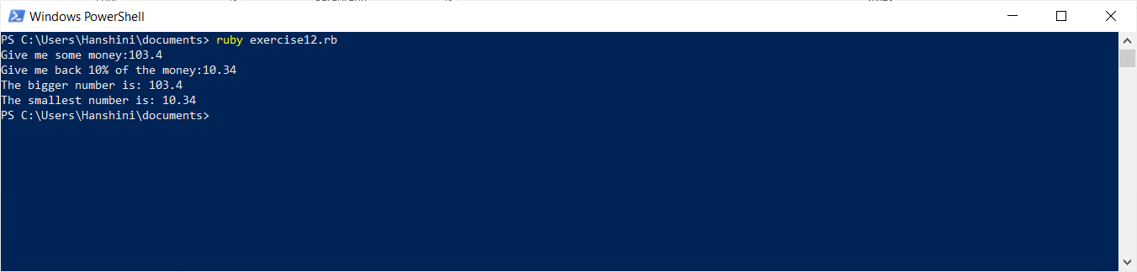

Exercise 13

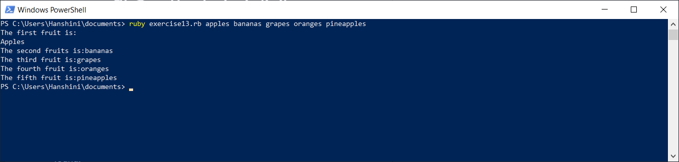

Exercise 14

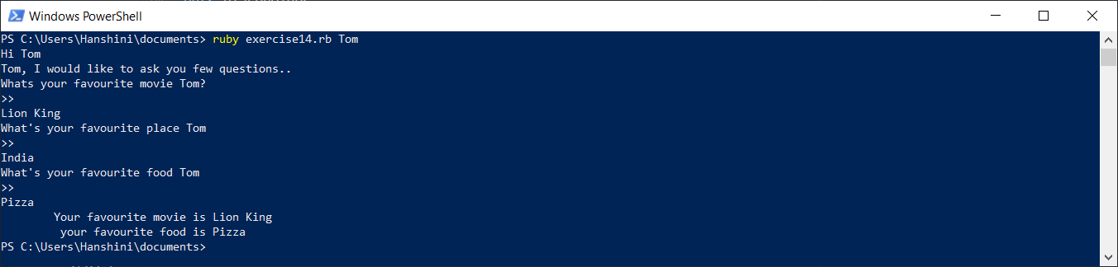

Exercise 15

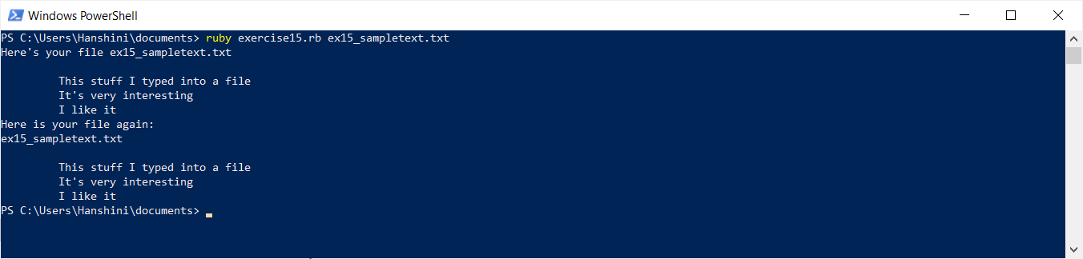

Exercise 16

